npx create-next-app@latest

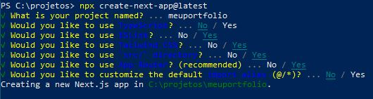

npm install react-type-animation

npm install react-animated-numbers

npm install @heroicons/react

npm install nodemailer

npm install dotenv\*

npm install resend

npm install express